DATA ANALYSIS REPORT
Project Title: Saas Revenue and Churn Analysis Report
Prepared by: Farheen Muqadam
Date: 14-05-2026

1. Executive Summary
- Objective: Analyze customer churn patterns across plans, acquisition channels, regions, and customer segments to identify key drivers and recommend retention strategies.
- Overall Churn Rate: The business is experiencing a high churn rate of 52.1%, indicating significant customer attrition and potential revenue loss.
- Key Finding 1 (Plan-Based Risk):
- Starter plan shows the highest churn (71%), followed by Professional (48%).
- Enterprise customers have the lowest churn (22.%).
- Key Finding 2 (Acquisition Channel Impact):
- Referral (61%) and Partner channels (58%) have the highest churn.
- Direct Sales has the lowest churn (39%).
- Key Finding 3 (Regional Risk):
- Latin America (62%) and Europe (55%) show the highest churn rates.
- North America has the lowest churn (49%).
- Business Impact: High churn in low-tier and certain acquisition channels is likely eroding revenue stability and increasing customer acquisition pressure.
- Recommendation:
  - Improve value proposition and onboarding for Starter & Professional plans
  - Optimize acquisition strategy—reduce reliance on high-churn channels (Referral, Partners)

2. Problem Statement
CloudTask Pro, a SaaS company, has rapidly scaled its customer base from 0 to 600 customers since 2022. Despite strong revenue growth, the company is experiencing a relatively high churn rate, raising concerns among senior leadership regarding long-term sustainability and customer retention.
The CFO has specifically highlighted the need to better understand:
- Monthly churn trends and whether churn is increasing over time
- Customer segments that are most at risk of churning
- The company’s unit economics, including revenue per customer and the relationship between customer acquisition cost (CAC) and customer lifetime value (CLV)
This analysis aims to:
- Identify key drivers of churn across customer segments
- Evaluate churn patterns over time
- Assess business profitability through core SaaS metrics (MRR, CLV, CAC)
- Provide actionable recommendations to improve retention and optimize growth strategy

3. Data Overview
- Data Source(s): internal database (subscription, Monthly Revenue)
- Time Period: Feb 2022 – Dec 2025
- Dataset Size: Subscription (600 rows -17 columns), Revenue (49 rows- 8 columns)
- Key Variables:
  - plan
  - billing_cycle
  - Company_size
  - Acquisition channel
  - Region
  - Monthly_revenue
  - Churned_date
  - Churned(yes/No)
  - Nps_score
  - Feature_usage Pct
  - New_customers
  - Churned_customers
  - Average_revenue_per_customer
  - Customer_acquisition_cost
  - Total_mrr

4. Data Preparation
- Feature engineering:
  - Churn flag(0,1)
  - Customer lifetime
  - CLV
  - Feature_usage_segment (high risk, medium risk, low risk)
  - CLV:CAC
  - New_mrr
  - Churned_mrr
  - Net_customer_growth
- Tools used:
  - Excel (Pivot tables, charts, calculated fields, formulas)

5. Exploratory Data Analysis (EDA)

5.1 Overall Trends
- Overall churn rate: 52%
- Churn rate shows increasing trend overtime
- MRR shows increasing trend overtime despite the churn rate

5.2 Segment Analysis
- By Plan Type:
  - Highest churn is observed in Starter plan (70.5%), followed by Professional (48%)
  - Enterprise customers show the lowest churn (22%), indicating stronger retention among higher tier user
- By Acquisition Channel:
  - Customers acquired via Referral (61.3%) and Partner channels (58%) exhibits highest churn rates
  - Direct Sales customers have the lowest churn(39.3%) ,suggesting higher-quality acquisitions.

- By Region:
  - Latin America (61.7%) and Europe (54.9%) shows the highest churn rates
  - North America (48.9%) has the lowest churn, indicating better retention performance in this region
- By Company Size:
  - Customers with 500+ employees (63.2%) and 1-10 employees (56.7%) show elevated churn rates
  - Mid segments (51-200 employees) demonstrate relatively lower churn (42.6%).

5.3 Distribution Analysis
- The customer base is distributed across multiple segments, with a significant concentration in medium-risk (254 customers) and high-risk (223 customers) categories.
- Churn distribution is skewed toward:
Lower-tier plans (Starter)
Certain acquisition channels (Referral, Partner)
Specific regions (Latin America, Europe)
→ This indicates that churn is not random but concentrated in identifiable high-risk segments.

6. Key Insights

Insight 1: Churn is concentrated in lower-tier plans
- Observation: Starter plan has the highest churn rate (60.2%) compared to Enterprise (22.2%) and Business (27.4%)
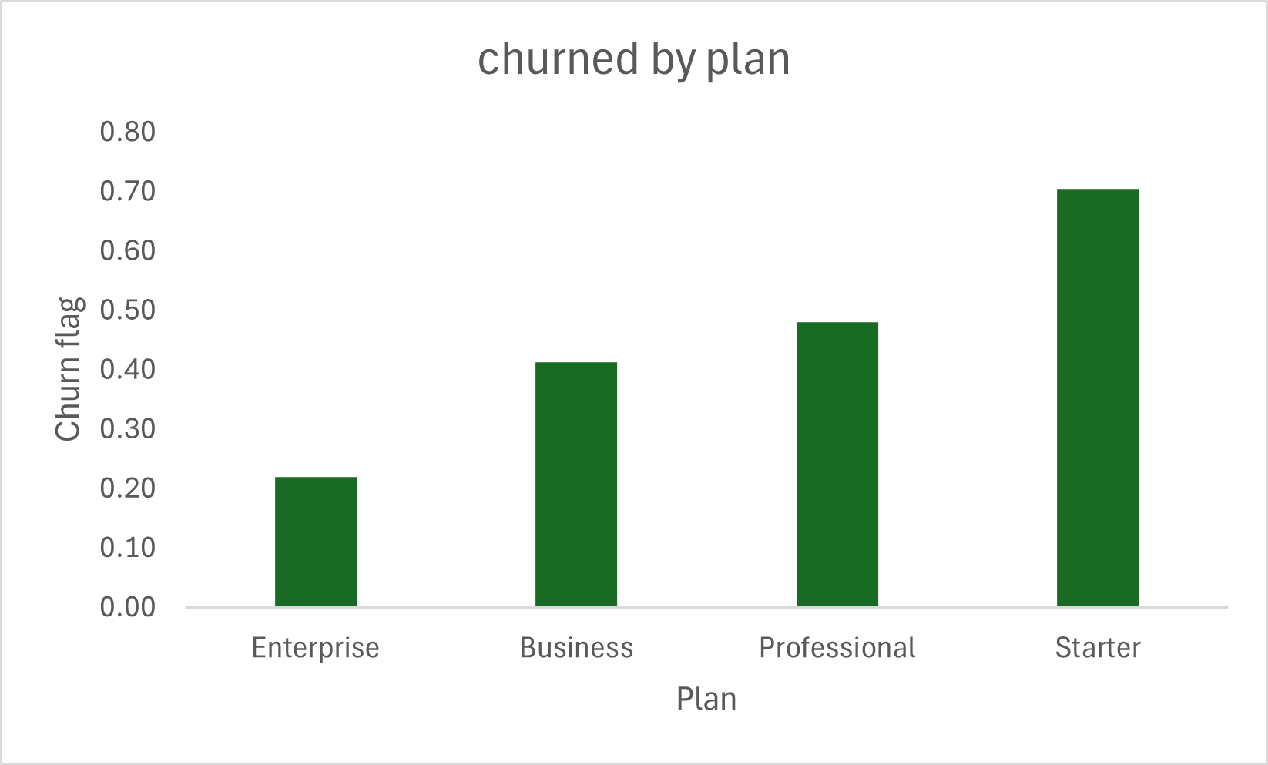
- Evidence: as shown in chart below starter plan churn(70%) is significantly higher than enterprise(22%)

- Business Meaning: Lower-tier customers likely perceive lower value or are more price-sensitive, making them more likely to churn. This suggests a gap in value delivery or onboarding for entry-level users

Insight 2 : Acquisition channel significantly impacts customer quality
- Observation: Customers acquired via Referral (61.3%) and Partner channels (58%) show the highest churn, while Direct Sales (39.3%) has the lowest churn.
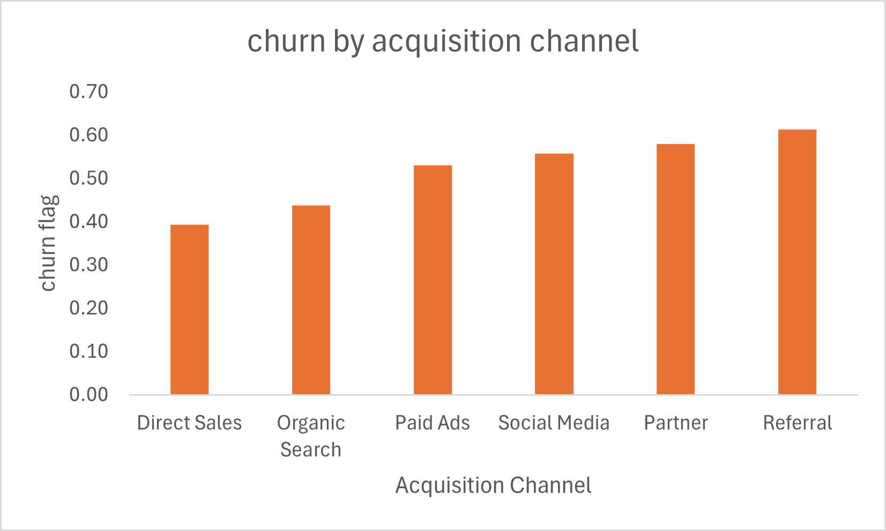
- Evidence: Referral (61.3%) vs Direct Sales (39.3%) as shown in the chart below
- Business Meaning: Not all acquisition channels bring high-quality customers. Heavy reliance on high-churn channels increases acquisition costs and reduces long-term profitability.

Insight 3: Billing cycle significantly impacts churn
- Observation: Customers on the monthly billing cycle (~60%) have a significantly higher churn rate compared to those on the annual billing cycle (~40.3%).
- Evidence: Billing cycle segmentation from the pivot table shows a clear gap in churn rates between monthly and annual subscribers. (Refer to Chart: Churn Rate by Billing Cycle)
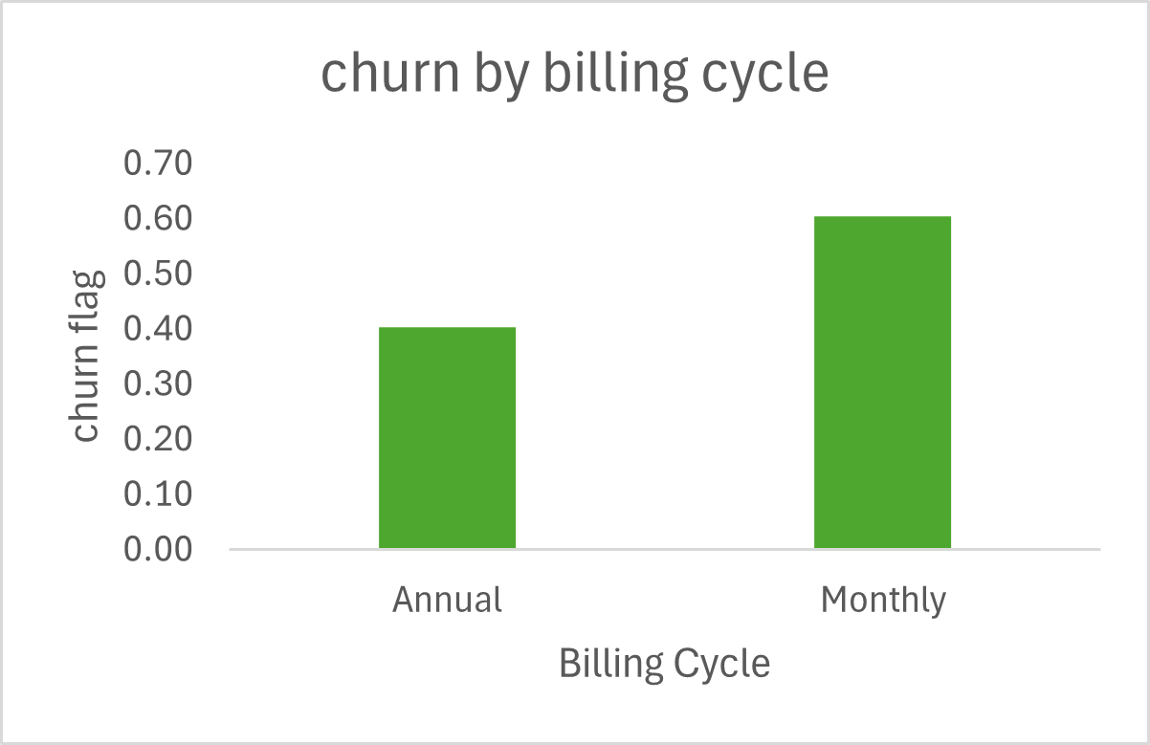

- Business Meaning: Customers on monthly plans have lower commitment and can churn more easily, while annual plans create stronger retention through longer-term contracts. This indicates an opportunity to shift customers toward annual plans to improve retention and revenue predictability.

Insight 4 : Churn is geographically concentrated
- Observation: Latin America (61.7%) and Europe (54.9%) have significantly higher churn compared to North America (48.9%)
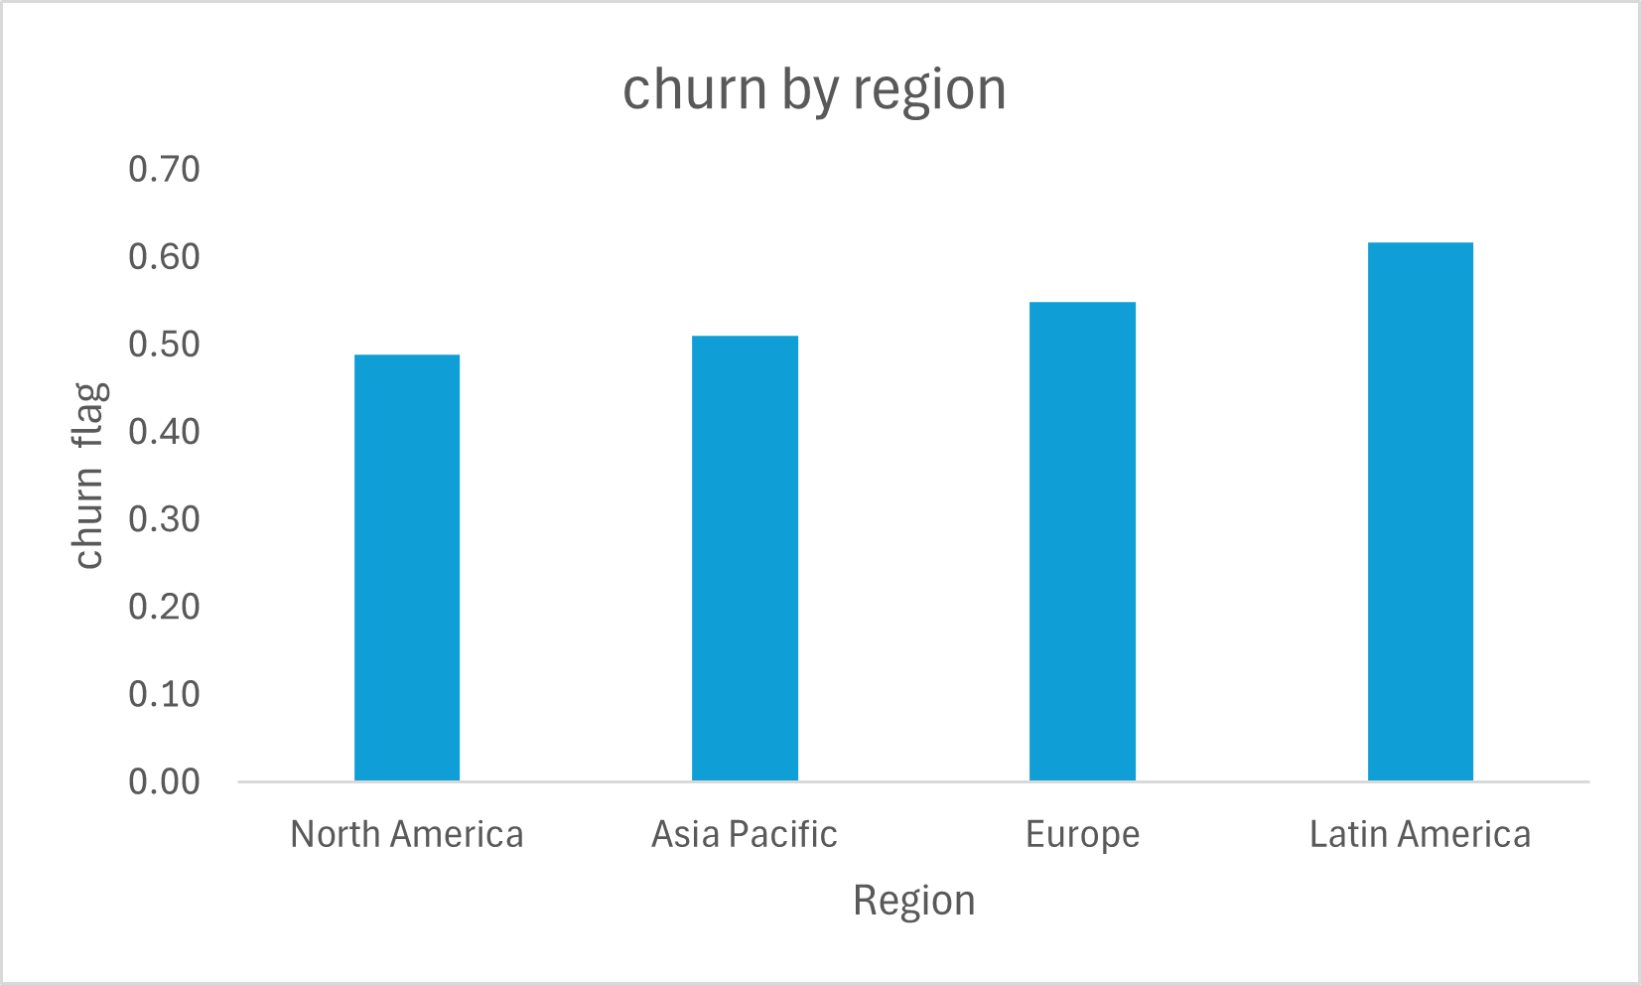
- Evidence: Latin America (61.7%) vs North America (48.9%) as shown in the chart below

- Business Meaning: Regional factors such as pricing sensitivity, competition, or product-market fit issues may be driving churn, requiring localized strategies

Insight 5: Mid-to-large companies show unexpectedly high churn
- Observation: Companies with 500+ employees (~63.2%) and 1-10 employees (~56.7%) exhibit higher churn than mid segments
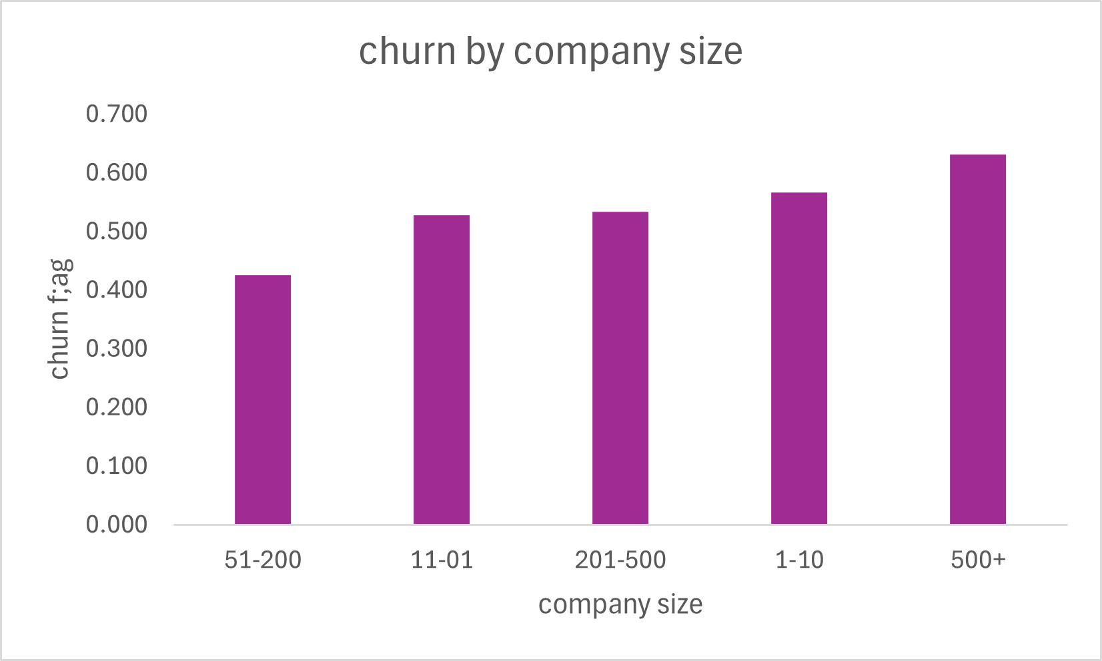
- Evidence: 500+ employees (~63.2%) vs 51-200 employees (~42.6%)

- Business Meaning: Larger customers may have higher expectations (features, support, customization). Failure to meet these expectations increases churn risk despite higher revenue potential.

Insight 6: Churn is driven by both economic and product factors
- Observation: Top churn reasons include Budget Cuts (53), Price too High (51), and Company closed (48)
- Evidence: Budget Cuts (53) and price too high (51) highest churn reason as shown in chart
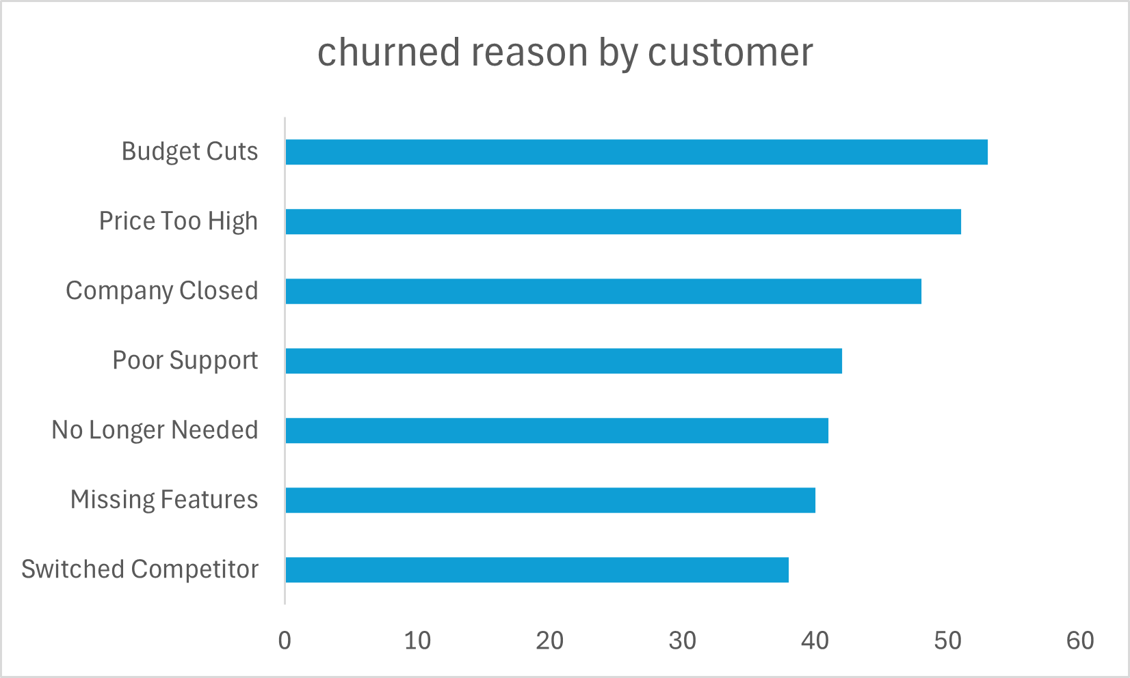

- Business Meaning: Churn is not caused by a single factor—both macroeconomic conditions and product gaps must be addressed to improve retention.

7. Key Metrics & KPIs
Metric | Value | Explanation
Total Customers | 600 | Total user base
Churn Rate | 52% | % customers lost
Revenue / MRR | $292628.6 | Monthly recurring revenue
CLV | $15965.92 | Customer lifetime value
CAC | 200 | Customer acquisition cost
CLV:CAC | 79.8:1 | Profitability ratio

8. Visualizations
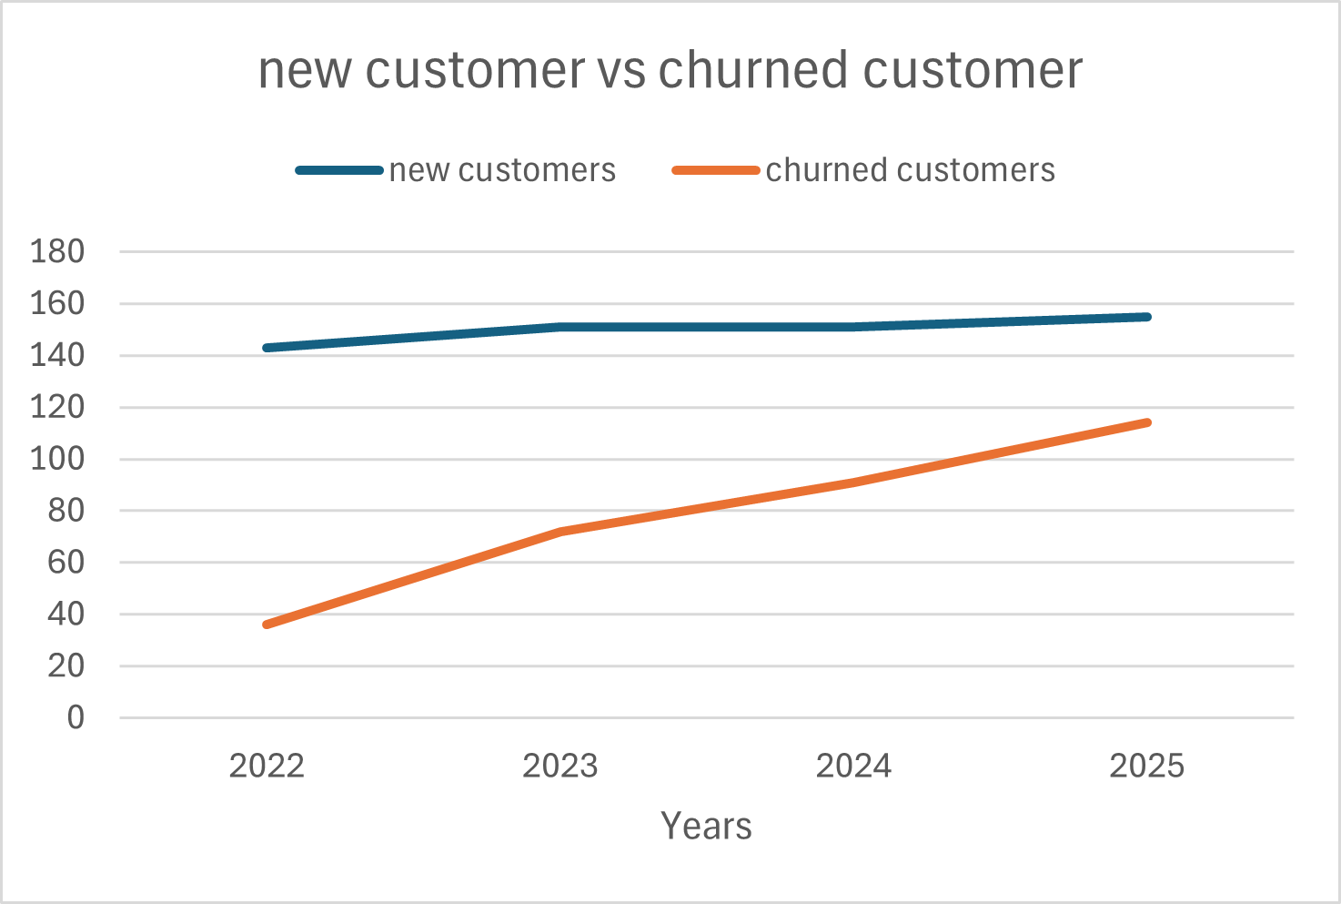
- Chart 1: as per the chart churned customers are rapidly increasing than new customers

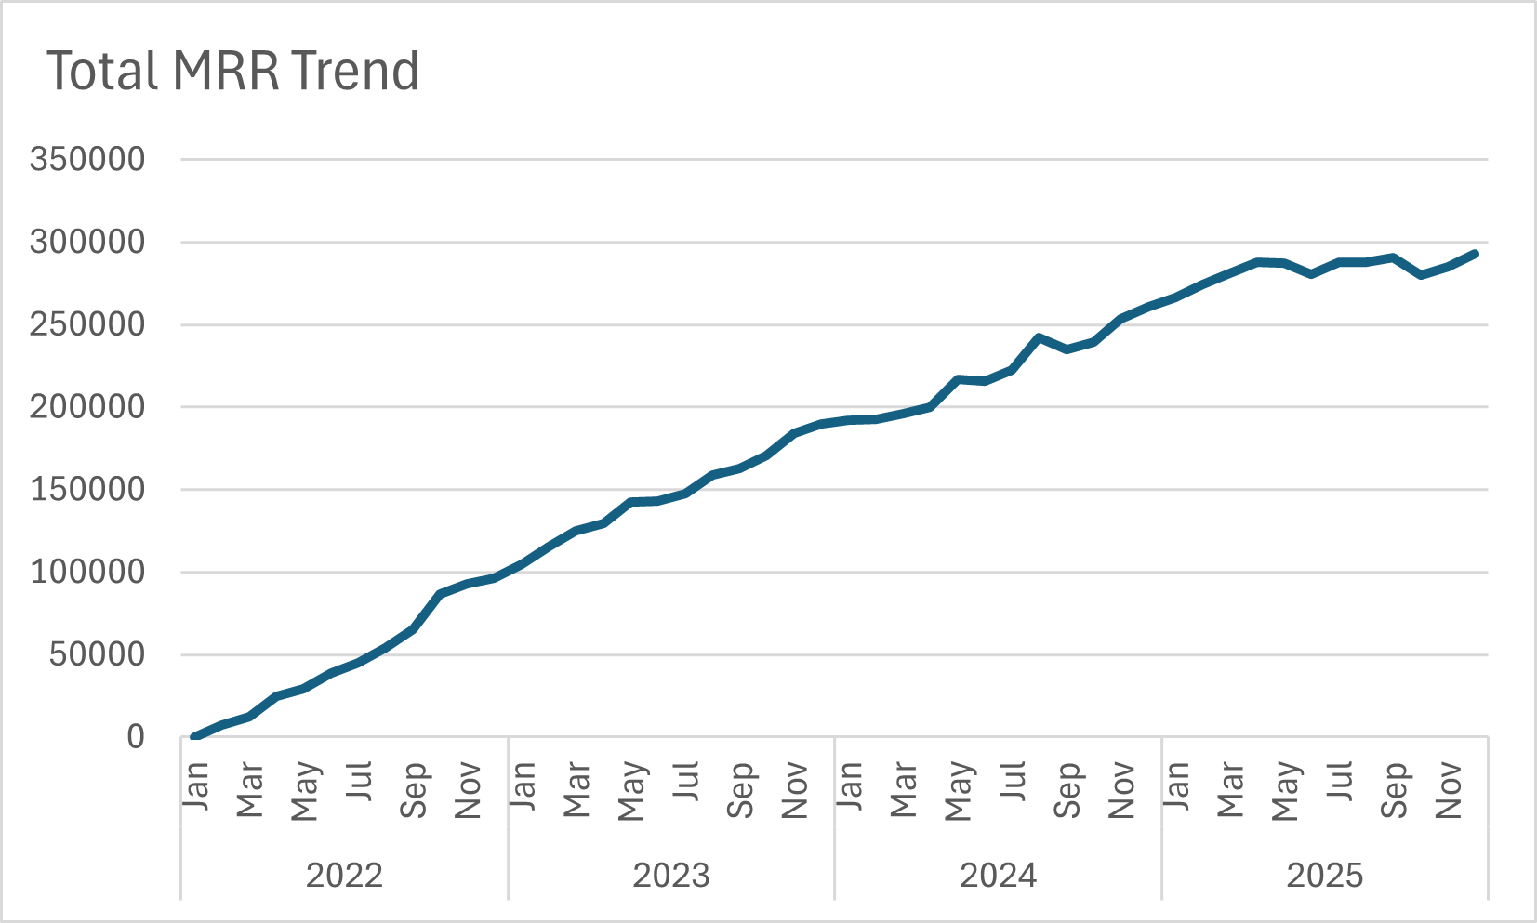
- Chart 2: as per the chart, MRR is increasing steadily

- Chart 3: as per the chart, enterprise plan has high CLV as compared to Starter plan
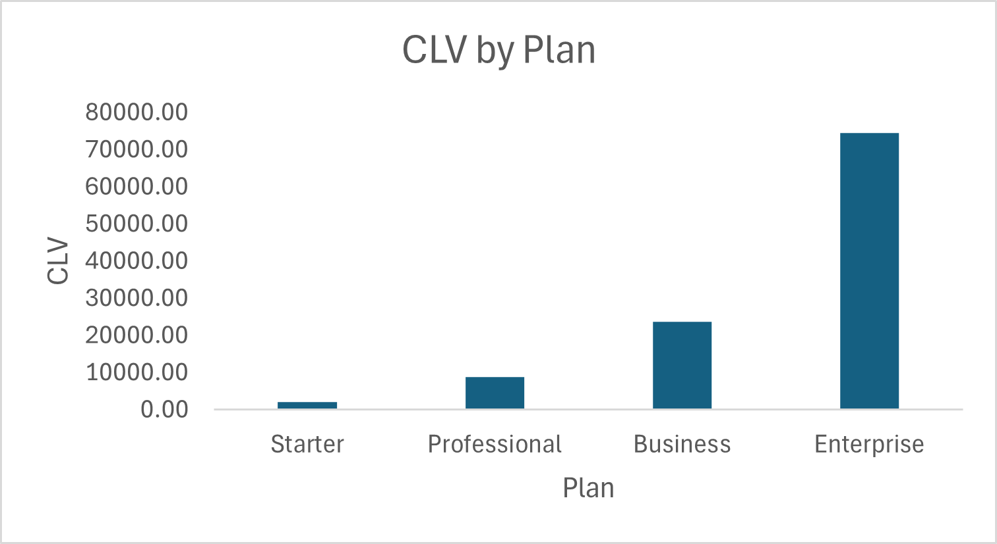

- Chart 4: as per the pie chart, 37% of customers comes under high risk segment.
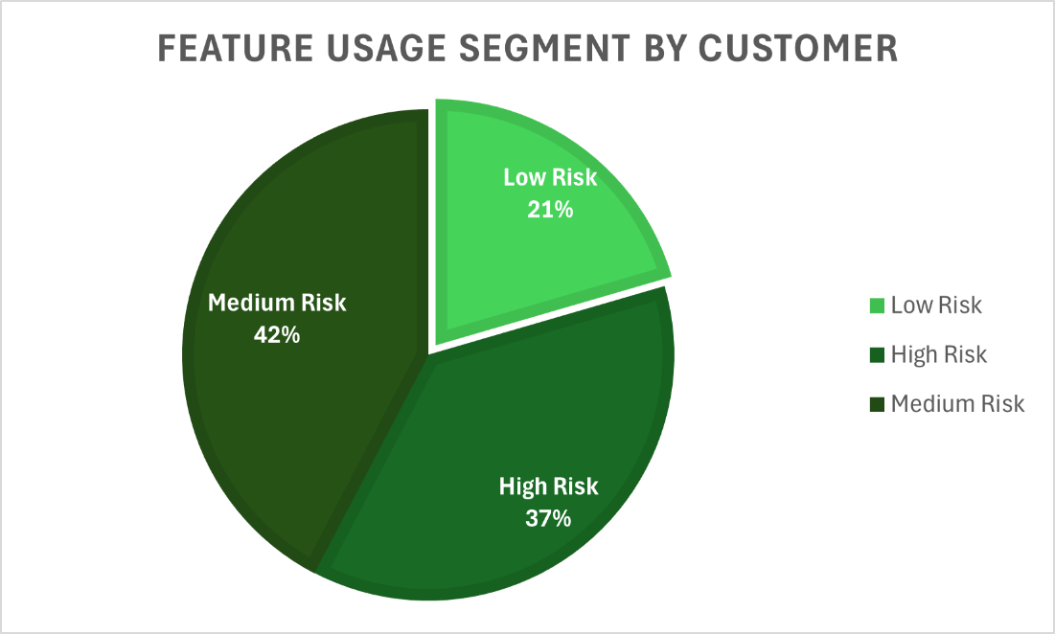
,

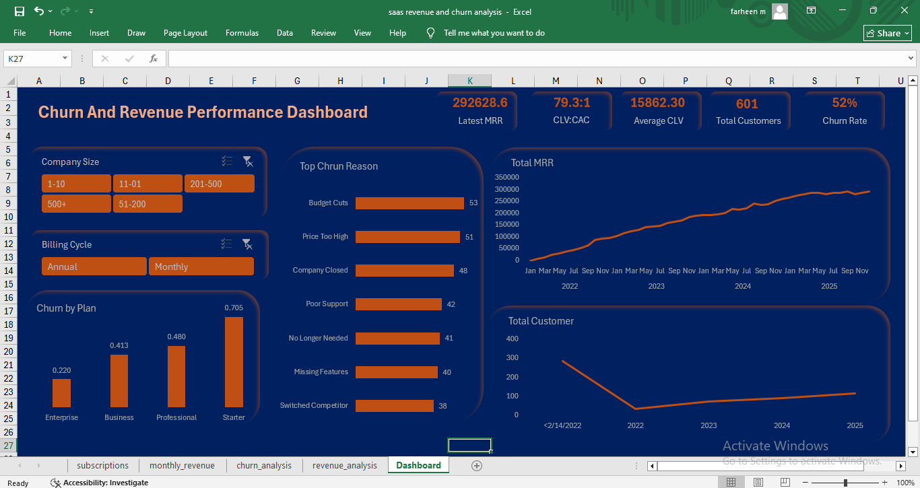
9. Dashboard Overview

10. Recommendations

Recommendation 1: Improve value proposition and onboarding for lower-tier plans
- Action:
  - Enhance onboarding for Starter & Professional users
  - Introduce feature improvements / guided usage
  - Introduce feature bundling or limited premium features in lower-tier plans
- Expected Impact:
  - Reduce Starter churn from 70.2% → ~62-64% (10–15% relative reduction)
  - Improve overall churn rate from 52.1% → ~47-49%
  - Increase CLV of Starter users (currently lowest) by ~10–20%

Recommendation 2: Optimize acquisition strategy toward high-quality channels
- Action:
  - Shift focus from Referral (61.3% churn) & Partner (58%)
  - Invest more in Direct Sales (39.3%)
- Expected Impact:
  - Reduce overall churn by ~3–5% by improving customer quality
  - Improve CLV:CAC ratio beyond current ~79:1
  - Increase retention of newly acquired customers by ~20–30%

Recommendation 3: Promote annual billing to improve retention
- Action:
  - Offer discounts or incentives for switching from monthly to annual plans
  - Highlight cost savings and long-term value in pricing communication
- Expected Impact:
  - Reduce churn from ~60% (monthly) toward lower annual churn (~40%)
  - Improve revenue predictability and customer lifetime value

Recommendation 4: Implement region-specific retention strategies
- Action:
  - Focus on Latin America (61.7%) & Europe (54.9%)
  - Adjust pricing / support / localization
- Expected Impact:
  - Reduce churn in underperforming regions
  - Improve global retention consistency

Recommendation 5: Address product and support gaps
- Action:
  - Prioritize feature development based on “Missing Features” feedback
  - Strengthen customer support responsiveness and quality
- Expected Impact:
  - Reduce product-related churn drivers (~40 missing features, ~42 poor support)
  - Improve customer satisfaction and retention

Recommendation 6: Target high-risk customers proactively
- Action:
  - Identify high-risk customers (66 customers) and run retention campaigns (emails, offers, check-ins)
  - Use engagement tracking to intervene early
- Expected Impact:
  - Reduce churn in most vulnerable segments
  - Improve overall retention rate

11. Limitations
- Data limitations: analysis based on historical data only
- Assumptions made: Assumptions made in segmentation
- Potential biases: no behavioral data (e.g. ,app usage depth) included

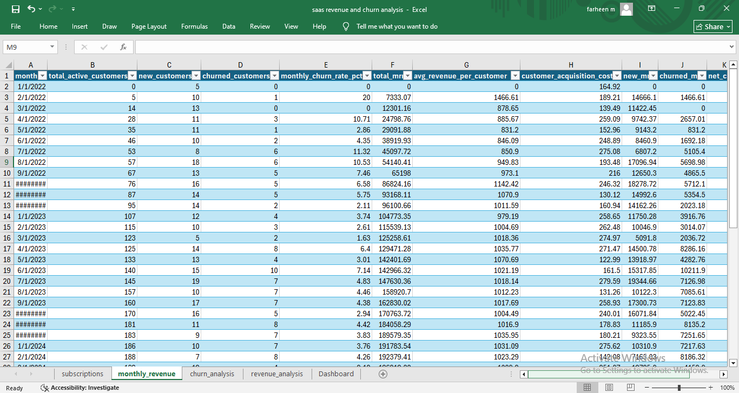
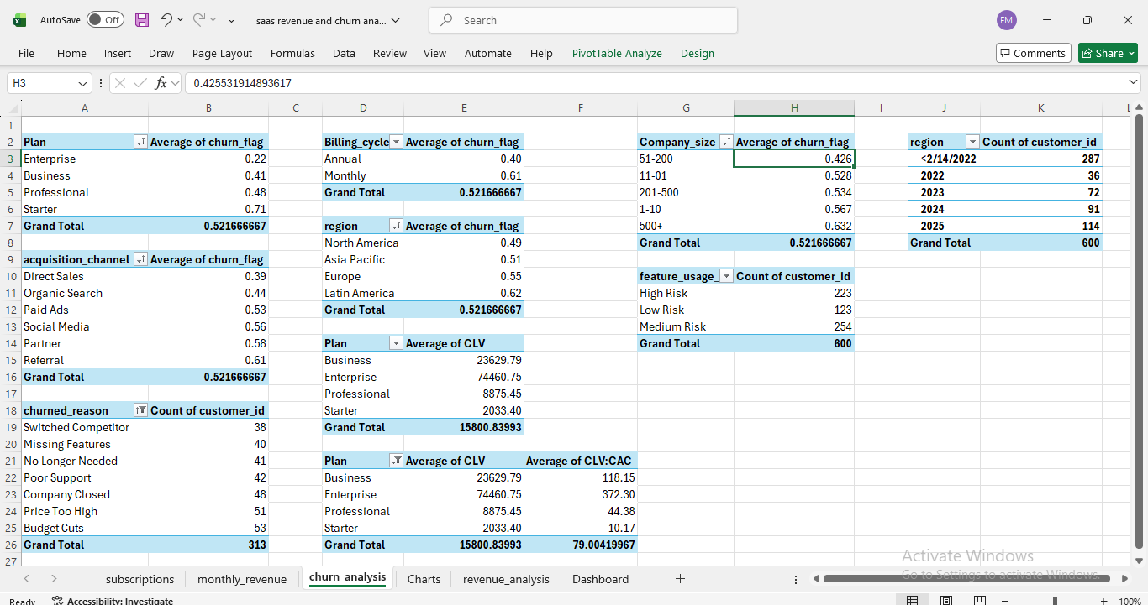
12. Appendix

